

KINGSWAY CHRISTIAN COLLEGE
Year 12 ATAR Physics 2017

Task 2
Test: Gravity, Satellites, Motion and Torque.
Name __An Swerkey___

Date due: Friday, 17 March 2017
Time allowed 80 minutes
Section A | Available mark | Student mark
Question 1 | 7
Question 2 | 7
Question 3 | 7
Question 4 | 8
Question 5 | 17
Question 6 | 14
Question 7 | 8
Question 8 | 10
Question 9 | 8
Total marks | 86
% | 100

Section A: Short answer questions. Write the answers in the spaces provided.
1. A projectile is fired from position 1 on a very windy day and its path is affected by the wind effects (resistance and drag). The initial velocity is shown as $\vec{u}$.
a) Draw and label on the same diagram, the path the projectile would have taken, if there was no wind. [2]

b) Use arrows to indicate the total velocity and total acceleration at the positions labelled 2, 3, 4, 5 and 6. Point 6 is just before landing. [5]
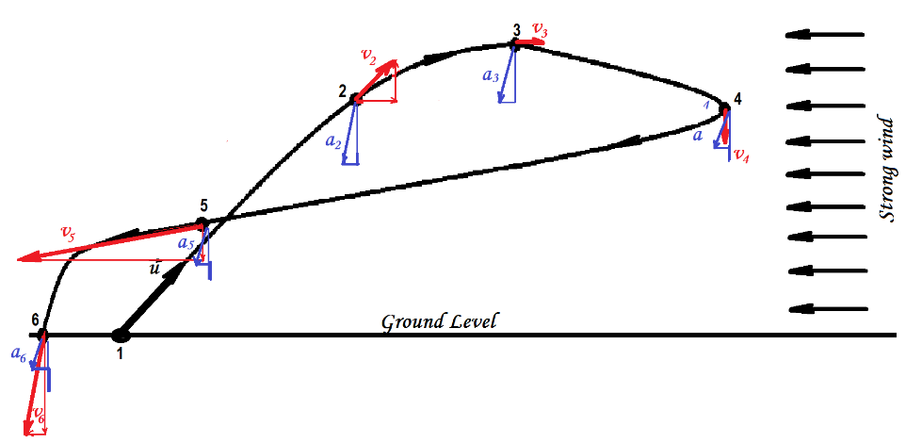
½ mark for each correct arrow for total velocity or total acceleration at a point. (Some vector addition should be shown)

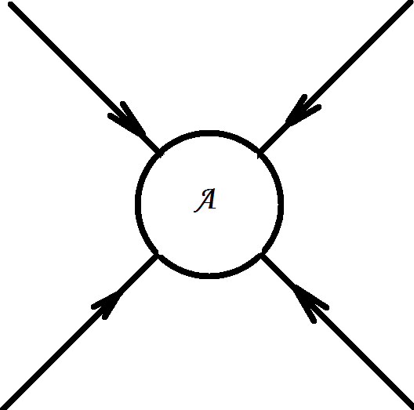
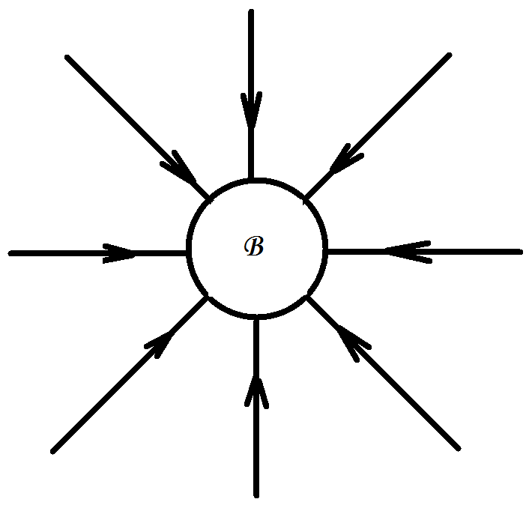
2. a) The gravitational field around an object A with mass m is shown below. Draw the gravitational field for an object B of the same size but with mass 2m. [2]

B has twice
as many
lines evenly
spaced.

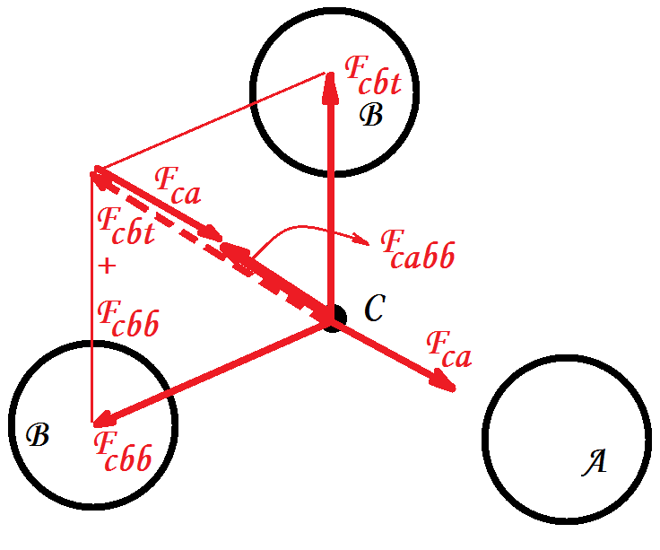
b) Objects A (mass m), B (mass 2m) and C (mass m) are positioned as shown. C at the centre and A and 2 × B at the vertices of an equilateral triangle.
Draw vectors to represent the following:
i) The force on C due to A, F_{c a} [1]
ii) The force on C due to the top B F_{c b t} [1]
iii) The force on C due to the bottom B F_{c b b} [1]
iv) The resultant force on C due to A and 2 × B. F_{c a b b} [2]
(Note magnitude of F_{cb} = 2 × F_{ca}; each force directed from C
to object; arrows shown, force diagram used to show
addition and resultant)

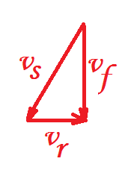
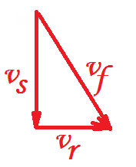
3. a) Two rowers, who can row at the same speed in still water, set off across a river at the same time. One heads straight across and is pulled downstream somewhat by the current. The other one heads upstream at an angle so as to arrive at a point opposite the starting point. Which rower reaches the opposite side first? [3]
Straight ahead rower (½)
upstream rower (½)

v_{s} is the rowing speed of each rower in still water,
v_{r} is the velocity of the river
v_{f} is the resultant rowing velocity
Straight ahead rower will arrive first because the velocity across the stream = v_{s} and if the stream is w metres wide, then time to cross = $\frac{w}{v_{s}}$. The speed across the river for upstream rower is v_{f}. 
$v_{f}= \sqrt{{v_{s}}^{2}-{v_{r}}^{2}}$ and this is less than v_{s}. Therefore, time to cross = $\frac{w}{v_{f}}$ will be bigger.

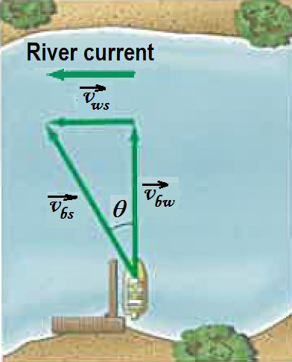
b) A boat that can move in still water with a speed $v_{bw}=1.85 m.s^{-1}$heads directly across the river whose current is $v_{ws}=1.20 m.s^{-1}$.
i) What is the velocity (magnitude and direction) of the boat relative to the shore, $\vec{v_{bs}}$ ? [2]
$v_{bs}=\sqrt{{v_{bw}}^{2}+{v_{ws}}^{2}}=\sqrt{{1.85}^{2}+{1.20}^{2}}=2.21 m.s^{-1}$
θ = $\tan^{-1}\left(\frac{1.20}{1.85}\right)=33.0^{0}$ 
The velocity = 2.21 m.s⁻¹ N33.0ºW or true bearing 327º
ii) If the river is 110 m wide, how long will it take to cross and how far downstream will the boat be then? [2]
N

Time to cross = $\frac{Displacement across}{Velocity in the direction of displacement}=\frac{110}{v_{bw}}=\frac{110}{1.85}=59.5 s$

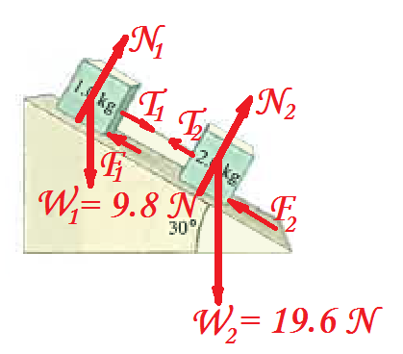
4. Two boxes, m₁ = 1.0 kg with friction = 0.20 times the normal reaction, and m₂ = 2.0 kg with friction = 0.10 times the normal reaction, are attached with an inextensible cord and placed on a plane inclined at θ = 30º .
a) Draw a free body diagram of the forces acting on m₁. [2]

N₁ = normal reaction on m₁ (½)
T₁ = tension on m₁, direction downslope (½)
F₁ = friction on m₁, direction upslope (½)
W₁ = weight of m₁, (½)

b) Draw a free body diagram of the forces acting on m₂. [2]

N₂ = normal reaction on m₂ (½)
T₂ = tension on m₂, direction downslope (½)
F₂ = friction on m₂, direction upslope (½)
W₂ = weight of m₂, (½)

c) Write the equations of motion in a direction parallel and perpendicular to the plane and solve for the tension in the cord and the acceleration of the system. [4]
For m₁ perpendicular to slope For m₂ perpendicular to slope
N₁ = W₁cos30 = 9.8cos30 = 8.487 N; N₂ = W₂cos30 = 19.6cos30 = 16.97 N;
F₁ = 0.2 × N₁ = 0.2 × 8.487 = 1.6974 N F₂ = 0.1 × N₂ = 0.1 × 16.97 = 1.697 N
Downslope Downslope
T₁ − F₁ + W₁sin30 = m₁a W₂sin30 − T₂ − F₂ = m₂a
T₁ − 1.6974 + 9.8 sin30 = 1 × a 19.6sin30 − T₂ − 1.697 = 2 × a
T₁ + 3.2026 = a ……i 8.103 − T₂ = 2a …. ii
Since it is the same string attached to both masses, T₁ = T₂ = T
The acceleration, a is the same for each
∴ i + ii
8.103 + 3.2026 = 3a
11.3056 = 3a
∴ a = 11.3056 ÷ 3 = 3.7685 m.s⁻¹
substitute in …..i
T = a − 3.2026 = 3.7685 − 3.2026 = 0.5659 N
Tension, T = 0.566 N; acceleration, a = 3.77 m.s⁻² downhill.

Section B: Problem solving. Answer the questions in the spaces provided. Show all working.
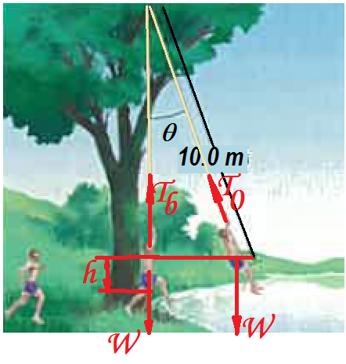
5. a) A 65-kg student runs at 7.0 m.s⁻¹ grabs a rope, and swings out over a lake. He releases the rope when his speed is zero.
i) What is the angle θ when he releases the rope? [2]
E_{k} at bottom = gain in E_{p} when speed is 0.
∴ ½ × 65 × 7² = 65 × 9.8 × h
h = (½ × 65 × 7²) ÷ (65 × 9.8) = 2.5 m
∴ θ = cos⁻¹((10 − h)÷ 10) = 41.4º
ii) What is the tension in the rope just before he releases it? [2]
At point of release, Net force towards centre = F_{c}
T₀ − Wcosθ = F_{c} = mv²/r but v = 0
∴ T₀ − 65 × 9.8 cos 41.4 = 0
∴ T₀ = 65 × 9.8 cos41.4 = 478 N
iii) What is the maximum tension in the rope? [2]
Maximum tension occurs at the bottom
Net force towards centre = F_{c} = mv²/r
T_{b} − W = F_{c} = mv²/r = 65 × 7²/10 = 318.5
T_{b} − 65 × 9.8 = 318.5
∴ T_{b} = 318.5 + 65 × 9.8 = 955.5 ≈ 956 N

b) A stunt driver wants to make his car jump over eight cars parked side by side below a horizontal ramp.
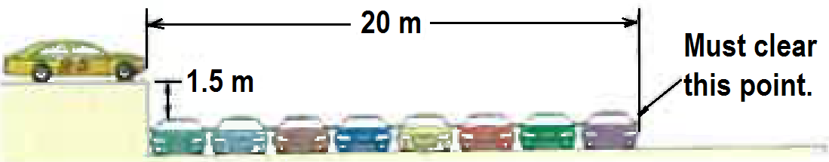
u
i) With what minimum speed in km.h⁻¹ must he drive off the horizontal ramp? The vertical height of the ramp is 1.5 m above the cars, and the horizontal distance he must clear is 20 m. [3]
X motion | Y motion
U_{x} = u, a_{x} = 0 | U_{y} = 0, a_{y} = − 9.8
S_{x} = u_{x}t = ut …..i | V_{y} = − 9.8t …..ii; s_{y} = − 4.9 t ²…..iii; v_{y}² = − 19.6 s_{y} …. iv
At must clear point, S_{x} = 20  so 20 = ut  ∴ t = 20/u | At must clear point, s_{y} = − 1.5; sub in ..iii − 1.5 = − 4.9 × (20/u)²  ∴ $u=20 \sqrt{\frac{4.9}{1.5}}=36.14 m.s^{-1}=36.14 3.6=130 km.h^{-1}$
ii) If the ramp is now tilted upward, so that ''take-off angle" is 10º above the horizontal, what is the new minimum speed in km. h⁻¹ ? [3]

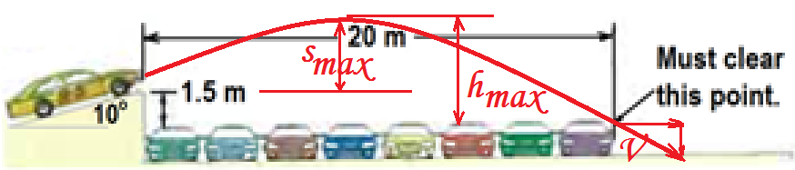

x motion | y motion
u_{x} = ucos10 = 0.9848u, a_{x} = 0 | u_{y} = usin10 = 0.1736 u, a_{y} = − 9.8
S_{x} = u_{x}t = 0.9848ut …..i | v_{y} = 0.1736u − 9.8t …..ii; s_{y} = 0.1736ut− 4.9 t ²…..iii;  v_{y}² = (0.1736u)²− 19.6 s_{y} …. iv
At must clear point, S_{x} = 20  so 20 = 0.9848ut  ∴ $t=\frac{20}{0.9848u}$ | At must clear point, s_{y} = − 1.5; sub in ..iii  $$1.5 = 0.1736u \frac{20}{0.9848u} 4.9 {\left(\frac{20}{0.9848u}\right)}^{2} \\ \frac{2020.97}{u^{2}}=5.026 u=20.1 m.s^{-1}=72.2 km.h^{-1}$$

iii) What is velocity of the stunt car as it crosses “Must clear this point.” [3]

At must clear point, $t=\frac{20}{0.9848u}=\frac{20}{0.9848 20.05}=1.013 s$
v_{x} = 0.9848 × 20.05 = 19.74 m.s⁻¹; v_{y} = 0.1736 × 20.05 − 9.8 × 1.013 = − 6.443 m.s⁻¹
θ = 18.1º
6.443 m.s⁻¹
19.74 m.s⁻¹
R = 20.77 m.s⁻¹

Resultant velocity is 20.8 m.s⁻¹ at 18.1º
downward from horizontal.

iv) What is the maximum height of the stunt car above the top of the lined cars? [2]

At maximum height v_{y} = 0
substitute in ….iv
v_{y}² = (0.1736u)²− 19.6 s_{y}
0 = (0.1736 × 20.05)² − 19.6 s_{y}
∴ s_{y} = (0.1736 × 20.05)² ÷ 19.6 = 0.6185 m
Maximum height = 1.5 + s_{y} = 1.5 + 0.6185 =2.1165 m ≈ 2.12 m

6. a) What is the difference between a geosynchronous and a geostationary satellite? [2]

Geosynchronous satellites orbit the earth once every 24 hours. They do not have to be equatorial orbits. Geostationary orbits are geosynchronous and have to orbit in an equatorial plane and orbit in the same sense as the earth rotates. They will always appear at the same position in the sky all the time. 

b) Calculate the altitude of a geostationary satellite and give two uses of such a satellite. [3]

$$Using T^{2}=\frac{4{}^{2}}{GM}r^{3}, then r= \sqrt[3]{\frac{GMT^{2}}{4 {}^{2}}}=\sqrt[3]{\frac{6.67 10^{-11} 5.97 10^{24} (24 3600)^{2} }{4 {}^{2}}}=42226910.18 m= altitude=r radius of earth \\ =42226910.18 6.37 10^{6}=35856910.18 m ≈35900 km above the earth.$$Uses of such a satellite: Communication; Radio/TV; weather; Relay broadcasting etc

c) A 1800 kg satellite is orbiting the earth at an orbital radius of 6.87 × 10⁶ m. Calculate
i) The gravitational force of attraction on the satellite [2]
$$F=G\frac{Mm}{r^{2}}=6.67 10^{-11}\frac{5.97 10^{24} 1800}{{\left(6.87 10^{6}\right)}^{2}}=15186.55 N$$
$≈15200 N towards earth^{'}s centre$
ii) The gravitational field strength of the earth at the orbit [2]
$g=G\frac{M}{r^{2}}=6.67 10^{-11}\frac{5.97 10^{24} }{{\left(6.87 10^{6}\right)}^{2}}=8.43697 N.kg^{1}=8.44 N.kg^{1}$ towards the earth’s centre.

iii) The acceleration due to gravity of the earth at the orbit [1]
The acceleration due to gravity g has the same value but different units from the gravitational field strength. ∴ g = 8.44 m.s⁻² towards the centre of the earth
iv) The period of the satellite in this orbit [1]
$${Using T}^{2}=\frac{4{}^{2}}{GM}r^{3} T= \sqrt{\frac{4 π^{2}}{GM}r^{3}}= \sqrt{\frac{4 π^{2} {\left(6.87 10^{6}\right)}^{3}}{6.67 10^{-11} 5.97 10^{24}}}=5669.76s \\ Period T=5670 s or 1 hr 34 min 29.8 s$$
v) The orbital speed of the satellite [1]
Orbital speed = $\frac{2 r}{T}= \frac{2 6.87 10^{6}}{5669.76}=7613.28 m.s^{-1}$ = 7610 m.s⁻¹
Or by using
$F=G\frac{Mm}{r^{2}}=m\frac{v^{2}}{r}$ will give $v=\sqrt{G\frac{M}{r}}=\sqrt{6.67 10^{-11} \frac{5.97 10^{24}}{6.87 10^{6}}}=7613.28 m.s^{-1}$
vi) The satellite is to be moved to an orbit with double the period. What will be the new orbital radius of the satellite? [2]
${Knowing T}^{2}=\frac{4{}^{2}}{GM}r^{3} or r^{3}= \frac{GM}{4{}^{2}}T^{2}$ then the ratio $\frac{r^{3}}{T^{2}}=\frac{GM}{4{}^{2}}$ is a constant.
∴ $\frac{{r_{2}}^{3}}{{T_{2}}^{2}}=\frac{{r_{1}}^{3}}{{T_{1}}^{2}} {r_{2}}^{3}={r_{1}}^{3} \frac{{T_{2}}^{2}}{{T_{1}}^{2}} r_{2}=r_{1} \sqrt[3]{{\left(\frac{T_{2}}{T_{1}}\right)}^{2}}=r_{1} \sqrt[3]{{\left(\frac{{2T}_{1}}{T_{1}}\right)}^{2}}$$$=6.87 10^{6} \sqrt[3]{{\left(2\right)}^{2}} =1.0905445 10^{7}m ≈1.09 10^{7}m$$

Or by using the previously calculated T = 5669.76s and new period = 2 × 5669.76 = 11339.52 s
and making r the subject in the formula ${ T}^{2}=\frac{4{}^{2}}{GM}r^{3}$ ;
$r= \sqrt[3]{\frac{GM}{4{}^{2}}T^{2}}= \sqrt[3]{\frac{6.67 10^{-11} 5.97 10^{24}}{4{}^{2}}{11339.52}^{2}}=1.0905441 10^{7} m$

7. A 1500 kg car is negotiating a circular roundabout with a radius r = 100m. At the instant shown it is heading North at 60 km.h⁻¹.
a) Calculate the sideways friction force, F required to keep the car in circular motion. [2]
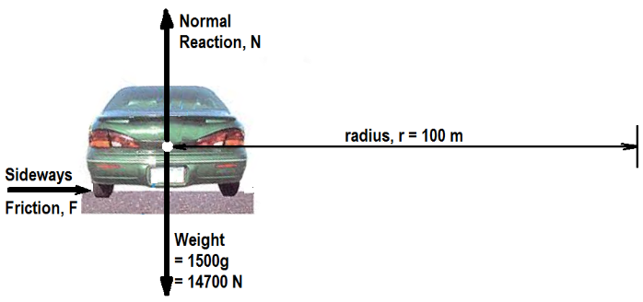
60 km.h⁻¹ = $\frac{60}{3.6}=16.67 m.s^{-1}$
The sideways friction provides the centripetal force, F_{c} = $\frac{mv^{2}}{r}=\frac{1500 {\left(16.67\right)}^{2}}{100}=4166.7 N$
F = 4170 N towards the centre of the roundabout.

b) The same car is now travelling at optimal speed (no tendency of sideways friction) on a ramp inclined at θ = 30º. The pathway is still circular with radius r = 100 m. Calculate the optimal speed required on this ramp. [2]
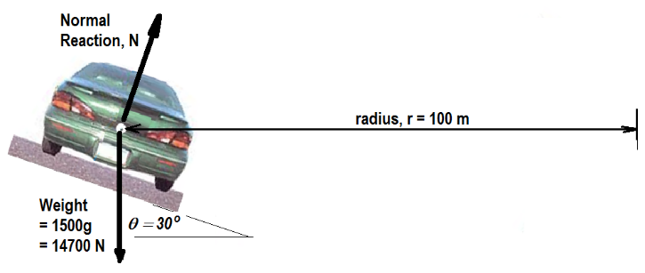
θ
Moving in horizontal circle so no vertical acceleration.
∴ $\sum{F_{y}=0 so Ncos=mg}$….i
Net force towards centre $\sum{F_{y}=F_{c}= \frac{mv^{2}}{r}}$
So $Nsin=\frac{mv^{2}}{r}$…..ii
$$\frac{ii}{i}: \frac{Nsin}{Ncos}=\frac{\frac{mv^{2}}{r}}{mg}=\frac{v^{2}}{gr}=tan$$∴ $v^{2}=grtan =9.8 100 tan 30=565.8 v= \sqrt{565.8}=23.7866 m.s^{-1}$
Optimal speed = 23.8 m.s⁻¹ or 85.6 km.h⁻¹
(Students don’t have to derive the equation, they can use it from memory)

c) The car is still on the 30º ramp and on the circular path with radius = 100 m. However, this time a sideways frictional force of 600 N acts up the slope as shown. Calculate the normal reaction, N and the car speed in km.h⁻¹. [4]
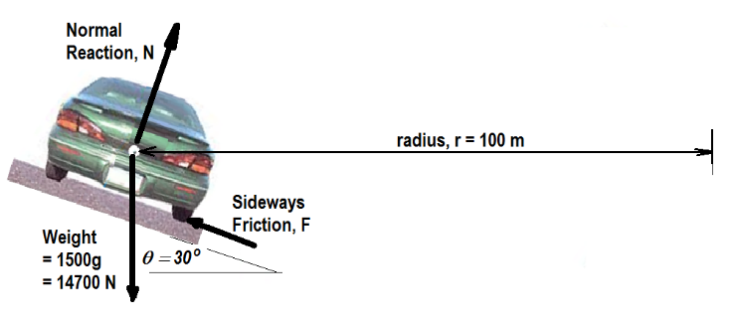
θ
Moving in horizontal circle so no vertical acceleration.
∴ $\sum{F_{y}=0 so Fsin+Ncos=mg}$….i
Net force towards centre $\sum{F_{y}=F_{c}= \frac{mv^{2}}{r}}$
So $Nsin -Fcos=\frac{mv^{2}}{r}$…..ii
i 600sin30 + Ncos30 = 1500 × 9.8 =14700
∴ Ncos30 = 14700 − 600sin30 = 14400 so $N= \frac{14400}{cos30}=16627.69 N ≈16600 N$up and perpendicular from plane.
using ii, $v= \sqrt{\frac{r \left(Nsin -Fcos\right)}{m}}=\sqrt{\frac{100 \left(16627.69sin30-600cos30\right)}{1500}}=22.795 m.s^{-1}$
car speed v = 22.8 m.s⁻¹ = 82.1 km.h⁻¹

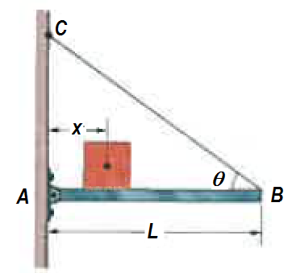
8. a) The length L of the uniform bar is 3.00 m and its weight is 200 N. Also, let the block's weight W = 300 N and the angle θ = 30º. The wire can withstand a maximum tension of 500 N.
i) What is the maximum possible distance x before the wire breaks? [2]
Using point A as pivot as two unknown forces act at that point and using moments equilibrium $\sum{τ}=0$
clockwise torques about A = anticlockwise torques about A
300 × x + 200 × 1.5 = 500 × 1.5
∴ x = 1.5 × (500 − 200) ÷ 300 = 1.50 m
ii) With the block placed at this maximum x, what are the horizontal and vertical components of the force on the bar from the hinge at A? [2]
300 N
200 N
T_{max} = 500 N
H_{A}
V_{A}
1.5 m
3sin30 = 1.5 m

$\sum{F_{H}}=0; H_{A}=500 cos30=433 N to the right.$

$$\sum{F_{V}}=0; V_{A}+500sin30 =300+200=500 V_{A}=500-250=250 N up$$

b) A diver of weight 580 N stands at the end of a diving board of length L = 4.5 m and negligible mass. The board is fixed to two pedestals, A and B, separated by distance d = 1.5 m. Of the forces acting on the board, what are the
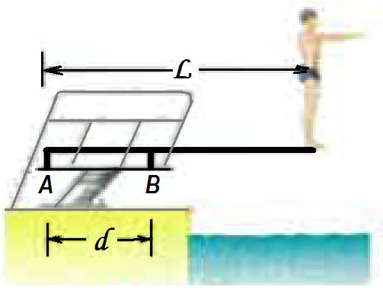
580 N
V_{A} V_{B}
i) magnitude and direction (up or down) of the force from the left pedestal A. [2]
Using B as pivot and using moment equilibrium
V_{A} × d + 580 × (L − d) = 0 ∴ V_{A} × 1.5 + 580 × 3 = 0
∴ V_{A} = −580 × 3 ÷ 1.5 = − 1160 N or 1160 N down
ii) magnitude and direction (up or down) of the force from the right pedestal, B? [2]
Summing the vertical forces
V_{B} + V_{A} = 580 so V_{B} = 580 − V_{A} = 580 − (−1160) = 1740 N up
iii) Which pedestal (A or B) is being stretched, and which is being compressed? [2]

Pedestal A is being stretched as the force on it from the diving board is equal and opposite to the 1160 force it applies downward on the diving board. It is being pulled up.
Pedestal B is being compressed as it is being pushed down by the equal and opposite force of 1740 N with which it pushes the diving board.
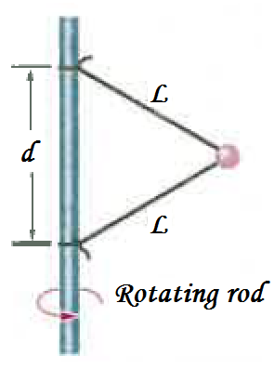
9. A 15.0 N ball is connected by means of two massless strings, each of length L = 2.00 m, to a vertical, rotating rod. The strings are tied to the rod with separation d = 2.00 m and are taut. The tension in the upper string is 1530 N. What are the
a) tension in the lower string, [2]
60º
30º
15 N
T = 1530 N
T_{L}
r
30º
Since d = l, the triangle is equatorial with all angles = 60º.
Ball is rotating in a horizontal circle r = Lcos30 = 2cos30 = 1.732 m
Ball has mass m = 15 ÷ 9.8 = 1.5306 kg
No ball acceleration in vertical direction ∴ $\sum{F_{y}=0}$ on the ball
∴ 1530sin30 = T_{L}sin30 + 15
∴ T_{L} = (1530sin30 − 15) ÷ sin30 = 1500 N
b) the net force $\vec{F_{net}}$ on the ball, and [2]

The net force on the ball is the resultant force towards the centre of the circular pathway
$\vec{F_{net}}=1530cos30+T_{L}cos30=1530 cos30+1500 cos30=2624.057 N$ towards the centre of the circle of rotation of the ball

$$\vec{F_{net}}=2620 N towards the centre of the circle of rotation of the ball.$$

c) speed of the ball in m.s⁻¹ and rpm [4]

Net force = F_{c} = $\frac{mv^{2}}{r} \frac{mv^{2}}{r}=2624.057 so v=\sqrt{\frac{2624.057 r}{m}}= \sqrt{\frac{2624.057 1.732}{1.5306}}=54.492 m.s^{-1}≈54.5 m.s^{-1}$

Let the rotation be x rpm
then $\frac{x 2 r}{60}=v so x= \frac{60v}{2 r}=\frac{60 54.492}{2 1.732}=300.44 rpm ≈300 rpm$

END of Task 2.

